# **Day 5 – Normalization Practice**

**Goal:** Using the non-normalized data below, draft an ERD in the box provided that shows the tables, their columns, and the relationships between the tables.

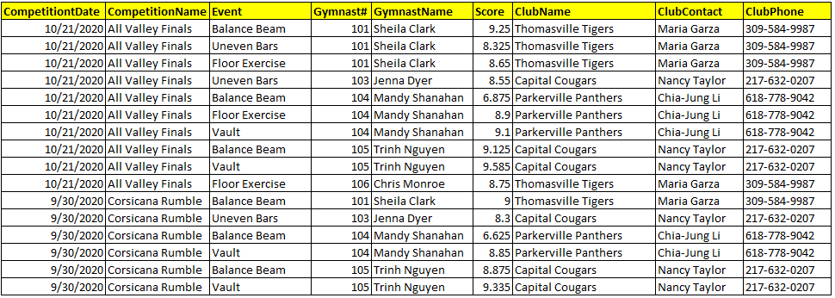

**Questions to consider:**

1. Where is there redundancy?
2. How can you split that redundant data out into its own entity or table?
3. As you split tables out do you need to assign a new PK?
4. Based on the relationship between the tables (i.e. 1-1, 1-m, m-m), where should you put a FK if needed?
5. Repeat steps 1-4 until you have an ERD in the 3NF.

|  |
| --- |
|  |